

**CS 319 - Object-Oriented Software Engineering**

**Analysis Report**

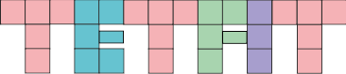

Section 1- Group 1F

Yasin Erdoğdu *21301118*

Mustafa Culban *21301187*

Irmak Akkuzuluoğlu *21401238*

Irmak Türköz *21400487*

**Deadline: 25/02/2017**

*Course Instructor: Bora Güngören*

Contents

**1.** **Introduction** 3

**2.** **Overview** 3

**3.** **Functional Requirements** 8

**4.** **Nonfunctional Requirements** 11

4.1 Performance Requirements 11

4.2 Reliability Requirements 11

4.3 User- Friendly Interface 12

4.4 Usability Requirements 12

4.5 Constraints 12

**5.** **System Models** 12

5.1 Scenarios 12

5.2 Use Case Model 14

5.3 Object Model 20

5.4 Dynamic Models 20

5.5 User Interface 20

**References** 27

1. **Introduction**

Tetfit is a game that can be considered as a tactical skill based game. The game’s main purpose is similar to Tetris which is for the player to gather as many points as he can. Points can be gathered through appearing bricks falling from the top of the game screen and accumulating at the bottom of the screen, whenever the letters shape a full horizontal line points will be earned. There will  a number of different shapes that look like certain letters of the alphabet which we will refer as bricks throughout this report.

This is a detailed analysis report of our project which consists of an overview that gives basic understanding of the game, functional and nonfunctional requirements, system models which include scenarios, use case model, object model, dynamic model and user interface.

1. **Overview**

We will implement a 2-Dimensions skill-based game called Tetfit. The game's main inspiration is the classical Tetris game. Tetfit is a single player game that can be played on PC for Windows. It will be implemented in Java language. The game will be composed of unit squares which come together to become letters I, J, L, O, S, T and Z which are the bricks of our game.

In the beginning, player starts with an empty screen and begins to fill the screen with the bricks falling from the top of the screen. When the squares on the game screen compose a full horizontal line; the line will disappear, upper boxes will fall down a unit below without deforming and the player's score will be incremented. The goal of the game is to score as high as possible. The game will end when a unit square of any letter hits the top of the screen. Moreover, there is also a mode called "Arcade Mode" which also has the same idea; however, the game is time-limited. While the time counter decreases every second, player should make full horizontal line as much as possible to extend the time back. The purpose is to get as much point as can before time hits 00:00. The game either end when the timer ends or when a unit square hits the top of the game screen. There will be difficulty levels in both modes Classic and Arcade. These levels are Beginner, Medium, Professional and All Star. All Star  level will be only included in Classic mode. In this difficulty level, there will be also obstacles at some unit squares in game screen except from extra game speed. From Beginner to All Star level, game speed will  be increased proportionally at each level. Moreover, when the game is over, if the player’s score is in the top 10 high scores and player wants to save  his/her score, it will be saved in high scores table.

Every kind of brick consists of four unit squares. They can be rotated based on the origin point which is the center of the 4x4 square that it sits on. The bricks are specified by their shapes and named accordingly because they look like certain letters which are I, J, L, O, T, S and Z.

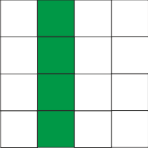

Figure 1 : I Shape

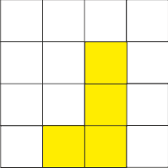

Figure 2 : J Shape

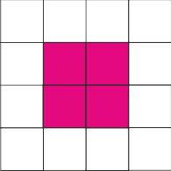

Figure 3 : O Shape

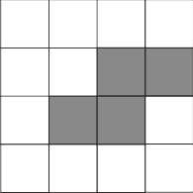

Figure 4 : S Shape

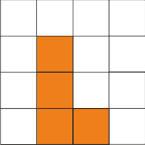

Figure 5 : L Shape

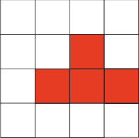

Figure 6 : T Shape

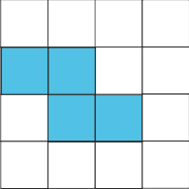

Figure 7 : Z Shape

2.1 Interactions with Bricks

While playing game, player supposed to place bricks to make a full line in the most

efficient way. To do this, player is able to move y- positions of bricks with keyboard left and keyboard right buttons. Also, player is able to turn the bricks. The bricks are rotate with respect to origin point (Figure .X).

→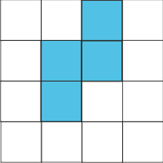→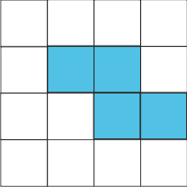

Figure 8 : Rotating Bricks

2.2 Levelling

When user create a new game, he will be able to select from one of levels, as name of the levels suggest, “Beginner level” will start with slow speed whereas “Pro” will start with high speed. On both Casual and Arcade mode, levelling up correlates with the score. As if score goes higher, player level up and the speed of the bricks will increase. The game has no end level, which means player can play infinitely many levels, however at some point it would be challenging to deal with the speed of the bricks. There is also “All-Star” level in Classic mode which include same logic inside of the game, however, there are obstacles that appear throughout gameplay which makes it more challenging.

1. **Functional Requirements**

3.1 New Game

The player will start the game  by pressing the “New Game”  button from the main menu. Game will start after player’s selection of the game level.

3.2 Play Game

The game is a typical tetris game with improved functionalities. With player selection of level while initiating a new game, play screen will change these selections accordingly. If player selects “Beginner” level the game will start from the lowest level “1” and the game speed will be the slowest because of player’s level. If player starts from “Medium” level, player’s game will start from a different game speed such as 10. If player starts from “Pro” level, player’s game initiates on the speed level of 20 for example. Lastly, if player selects “All-star” game mode which will has obstacles in it on the screen which player needs to avoid not to stumble them while moving your brick. This will be the only level that will have a obstacles . Game speed will be going to increase with your bricks broken respectively

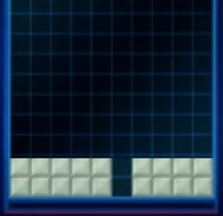

Figure 9 : Obstacles

After the game isinitiated, the bricks start falling from the top of the game screen to bottom and the player needs to locate them with a proper position that he desires in order to make a full line with these bricks. These bricks have different shapes for example with L, J, O, Z, S, T etc.  So player needs to think a way to align these up coming bricks to make a full line to destroy that line and empty the game screen as much as possible. Once player forms a line, that line immediately disappears and player gains point (Figure  10) . The main purpose is to make the highest score in the game. The game is endless state. So there won’t be a transaction between levels by screen changing. Instead of that, level will increase according to the points of the player which will increase the speed. There will be obstacles only on the “All-Star” level where obstacles will be randomized while localization of them by game itself.

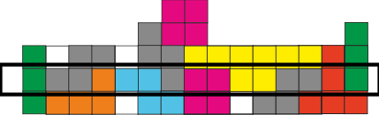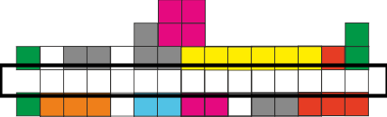   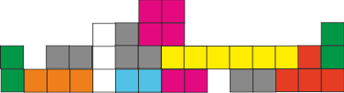

Figure 10 : Explosion

**Pause Game:**

Players are able to pause game at any time and they will be given the chance of continuing the game, saving the current game and restart the game. If they want to play no more, they can exit game without saving anything.

**High Scores:**

Top 10 scores will be kept  in the game. When the game is over, players will be able to save their scores with player name by clicking “Save Score” button if their scores can make it to the top 10 scores. Also, player will be able to see highest 10 scores by clicking “High Score” button.

**Credits:**

The game will offer information about game developers and players can reach this information by clicking “Credits” button. With this information, players can contact with game developers to give some feedback or suggestions for development of the game.

**Save Game:**

Players will able to save the current state of the game whenever they want. After the the game is paused, player can save game simply by clicking “Save Game” button.

**Load Game:**

The game will be able to hold saved games. Players can  load game by clicking “Load Game” button at the main menu. If there will be more than one saved games, player can choose any one of them. The games that were previously saved will listed with a tag which will be composed of the player name, dash, level that was reached, dash, the date it was saved.

**Resume Game:**

Player will be able to continue to his/her game  from the last state of the game. Continue Game option can be used if and only if the player has paused the game beforehand.

**Help/Tutorial:**

With Help Option,  players will be able to access necessary information about the Tetfit game. They can find a brief game description. They will learn easily how to play Tetfit game via the help option.

**Exit Game:** Player will be able to exit game by just clicking “Exit Game” button

1. **Nonfunctional Requirements**

4.1 Performance Requirements

* The game will not require much resource to play because there won’t be too much usage of the memory.  There can be a memory process threshold at least 512KB in 1 second.
* Response time of the game will not be a problem because of the slow flow even in the highest level of speed it will not be that fast.
* Highscores will be saved inside a .txt file with a proper format. Reading and printing them into a textbox will not take more than a second.

4.2 Reliability Requirements

* Options, high scores, saved games, tutorial and credit texts will be taken from a saved .txt files.

4.3 User- Friendly Interface

* The game will provide user-friendly interface to players in order to built comfortable environment for playing. Thanks to this feature, player will be able to understand and  play game easily. We are planning that user interface will not be filled with unnecessary and useless details.

4.4 Usability Requirements

* Game instructions are clear enough to follow. There is a Tutorial that shows you how to play game and it at most take 5 minutes to understand instructions.
* Game controls are really human understandable that it at most take 1 minute to understand how to control the blocks.

4.5 Constraints

* Game language will be in English.
* Space will be occupied at most 6MBs by Tetfit on your computer.
* It will be an open sourced software licensed program.
* Tetfit will be implemented in Java Programming Language.

1. **System Models**

5.1 Scenarios

**Scenario 1: Play Game**

Player Mr. Abdulkerimov wants to play Tetfit game. Before all, he has no idea what is Tetfit game and how it is being played. Firstly, to learn how to play immediately the necessary information will appear once he clicks “Help” button to see tutorials about Tetfit game. After reading tutorial, he will be capable of playing Tetfit game. After tutorials, he clicks “Return to Main Menu” button to come back main menu page. Afterwards,  he selects “New Game” option to play  new game. However, before he starts to play game, he also needs to select a game mode,  Casual Mode or Arcade Mode before starting to play. While Casual Mode has four difficulty levels such as Beginner, Medium, Professional and All Star, Arcade Mode has three difficulty levels such as Beginner, Medium, Professional. He chooses any difficulty levels of one of the game modes. Then, game screen will immediately be shown to player. When the game starts, time for the game also starts to flow. Player can easily see his score, the time he spent playing the particular game and his current level on the right of the screen. On the left of the screen, blocks start to fall down. He can easily direct these blocks to fit most proper position. He will be also aware of the next block which will fall down after the current one arrives at place. Next block will be shown on the right of the screen.

**Scenario 2: Load and Save Game**

Player Irmak starts the game. Main menu screen will appear on the screen. After it appears Irmak clicks to the “Load Game” button. She, then, chooses a game from a list which is listing game from most recently saved to the last saved, and the tags indicate when and who saved the game at which level. She chooses a game from there. So game screen will come and the blocks that where she stopped will be loaded to the screen exactly how she left them. After playing a while, she, then, decides to save the game. After pausing game, she does that by pressing “Save Game”. Game will save current game with the last settings and will return to the pause menu again.Then she presses “Exit Game” button to leave the game.

5.2 Use Case Model

**Use Case Name:** New Game

**Participating Actor:** Player

**Pre-Condition:** Player should select New Game option

**Post-Condition:**-

**Entry Condition:** Player should start the application and clicks “New Game” button from  
 Main Menu. The Level selection menu will be loaded successfully.

**Exit Condition:** Player clicks to the “Back to the main Menu” and player redirected to the

Main Menu.

**Main Flow  of Events:**

* Player runs the application.
* The system loads all the Main Menu items to the screen.
* Player clicks to the “New Game” button.
* Game redirects user to the “Select Level” screen.

**Alternative Flow of Events:**

**Use Case Name:** View High Score

**Participating Actor:** Player

**Pre-Condition**: -The system needs to keep some high scores.

-Player must be at Main Menu screen.

**Post-Condition:-**

**Entry Condition:** Player clicks “High Scores” button in the Main Menu screen.

**Exit Condition:** Player clicks “Return to Main Menu” button to return Main Menu

**Main Flow  of Events:**

-The player clicks “High Scores” button in the Main Menu screen.

-The system lists high scores in the top 10 score table.

**Alternative Flow of Events:**

-The player clicks “High Scores” button in the Main Menu screen.

-The system cannot list any scores, if there is not any saved score in the game.

**Use Case Name:** Save Score

**Participating Actor:** Player

**Pre-Condition:** -The game needs to over.

-Player must have enough score to be saved

**Post-Condition:-**

**Entry Condition:** Player clicks “Save Score” button in the Game Over screen

**Exit Condition:** Player clicks “Return to Main Menu” button to return Main Menu

**Main Flow  of Events:**

-The player gains points during the playing game.

-When the unit square of any brick touches to the upper part of the play screen, the system will  end the game.

-The system will offer the player to save score if the score in the top 10 scores.

-Player clicks “Save Score” button to save his/her score

**Alternative Flow of Events:**

-The player ends the game with enough score to be in the top 10 scores.

-The system does not offer the player to save score.

**Use Case Name:** View Credits

**Participating Actor:** Player

**Pre-Condition:** Player must be at Main Menu

**Post-Consition:-**

**Entry Condition:** Player clicks “Credits” button from Main Menu

**Exit Condition**: Player clicks “Return to Main Menu” button to return Main Menu

**Main Flow  of Events:**

-The player clicks “Credits” button in the  Main Menu screen.

-The system gives information about game version and game developers

**Alternative Flow of Events:**

**Use Case Name:** Sound On/Off

**Participating Actor:** Player

**Pre-Condition:** A click is needed.

**Post-Condition**:-

**Entry Condition:** Player clicks voice icon at right  down corner of  the game screen.

**Exit Condition:** -

**Main Flow  of Events:**

-The system starts the game with  game sound.

-The system will offer “Sound On/Off” button in the Main Menu Screen  and Pause Screen.

-The player can turn off or turn on again the game sound.

**Alternative Flow of Events:**

**Use Case Name:** View Help

**Participating Actor:** Player

**Pre-Condition:** Player must be at Main Menu

**Post-Condition:-**

**Entry Condition:** Player clicks “Help” button from Main Menu.

**Exit Condition:** Player clicks “Return to Main Menu” button to return Main Menu.

**Main Flow  of Events:**

-The player clicks “Help” button in the Main Menu screen.

-The system gives information about game playing.

**Alternative Flow of Events:**

**Use Case Name:** Load Game

**Participating Actor:** Player

**Pre-Condition:** There should be saved games in the game

-Player must be at Main Menu

**Post-Condition:-**

**Entry Condition:** Player clicks “Load Game” button from Main Menu.

   Player selects one of the saved games to play that  saved game.

**Exit Condition:** Player clicks “Return to Main Menu” button to return Main Menu.

**Main Flow  of Events:**

-The player clicks “Load Game” button.

- The system lists saved games at the  game screen.

-The player chooses one of them to start to play.

-The system loads last state of the choosen game  to the screen

**Alternative Flow of Events:**

-The player clicks “Load Game” button.

-The system lists empty screen, if there are not any saved games.

-The system cannot load any saved game

**Use Case Name:** Save Game

**Participating Actor:** Player

**Pre-Condition**: There should be paused game in the game

-Player must be at Pause Menu

**Post-Condition:-**

**Entry Condition:** Player clicks “Save Game” button from Pause Menu..

**Exit Condition**: Player clicks “Return to Main Menu” button to return End Game.

Player can click “Continue” button to continue to play pause-game.

**Main Flow  of Events:**

-The players select “New Game” option.

-The system lists game modes and difficulty levels.

-The player chooses one mode and level  to start playing.

-The system shows game screen immediately.

-The player starts to play game.

-The player clicks “Pause” button to stop the game.

-The system shows Pause screen to player.

-The player clicks “Save Game” button.

-The system saves last state of the game.

**Alternative Flow of Events:**

**Use Case Name:** Select Mode

**Participating Actor:** Player

**Pre-Condition:** Player should already select New Game option

**Post-Condition:**-

**Entry Condition:** Player clicks “New Game” button from Main Menu.

**Exit Condition:** -

**Main Flow  of Events:**

-The players select “New Game” option.

-The system lists game modes and difficulty levels.

-The player selects one difficulty level of Classic Mode or Arcade Mode.

**Alternative Flow of Events:-**

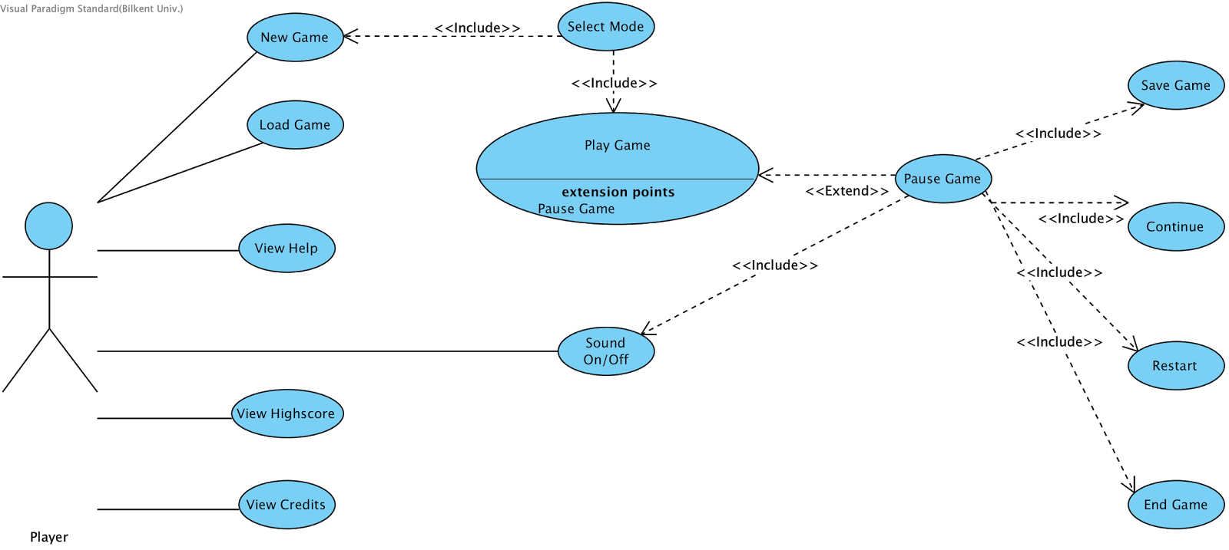

Figure 11 : Use Case Diagram

5.3 Object Model

5.4 Dynamic Models

5.5 User Interface

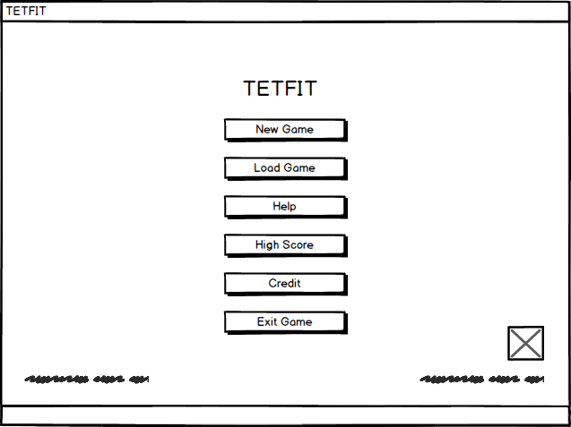

Figure 12 : Main Menu Screen

On the Main Menu Screen, we have buttons that can connect you to the desired place. “New Game” button for creating a new game and it redirects you to the “New Game” Screen. “Load Game” button opens the saved game into the txt file in a descending order of date. “Help ” button opens a new window and it gives you how to play game, and what is need to pass levels for example. “High Score” buttons opens a new window which include all time highscores and with the player’s nickname in it. “Credit” button directs you a new windows which includes Game’s developer’s name surname and maybe social account links. Credit Page will have a version of game and some other necessary things as we see in the popular games.  “Exit Game” button makes you to the leave the game and close all the processes that was running on your OS. We will have a sound on/off button to control the Tetfit’s sound’s. On the left down corner, game might have version number.

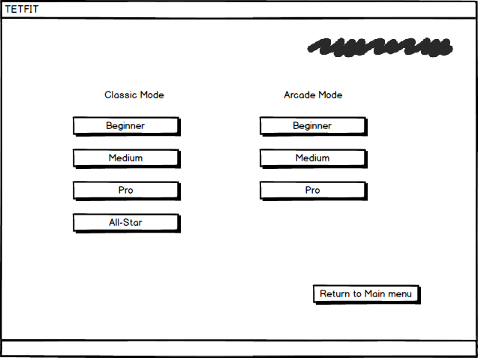

Figure 13 : New Game Screen

On the New game screen game will have both Arcade and the Classic mode clickable buttons for user to choose whatever way they like. We have Buttons “Beginner”, “Medium”, “Pro” and “All-Star” for the classic mode and the features of them explained in the Scenarios section. We also have “Beginner”, “Medium” and “Pro” for the Arcade mode and also the reason why we have 3 level on Arcade Mode was explained in the Scenarios section, too. Also We have Tetfit name on the upper right part of the window. “Return to the Main menu” button will be aligned on the right corner of the window. There might be a background image in order to give game a visualization.

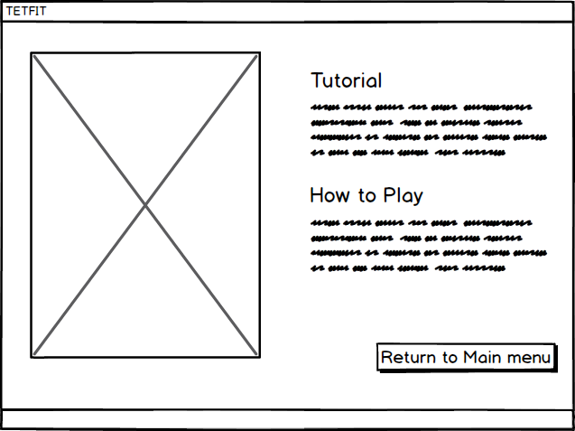

Figure 14 : Tutorial Screen

On the Tutorial Screen, Game will have a picture of the game objects such as brick, game table, player point section, time section, and the level pointer section in order to give information to the user what is what on the left side of the screen. On the right, game will gave Tutorial text for explanation for the user give info what to do in the game. On The How to Play part which will be located in the lower part of the right part of the screen, information will be given to the user how to move bricks, what to the while selecting game, loading game and some stuffs like these. “Return to the Main Menu” button will be located on the lower right corner of the screen. Game name will be located on the window name section.

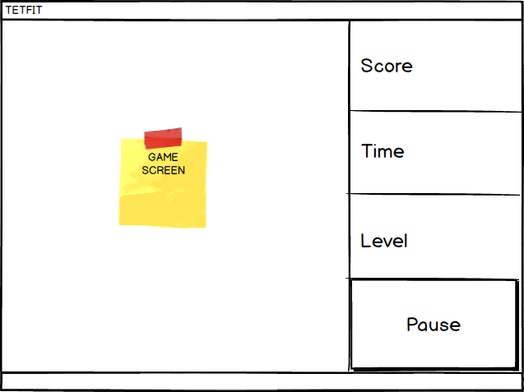

Figure 15 : Game Play Screen

On the game play screen, game will have a game screen mostly left of the screen. And on the right screen will have Score, Time and Level indicators to give information of the current game to the user momentarily.  On the right section window also will have “Pause” button for user to pause the game.

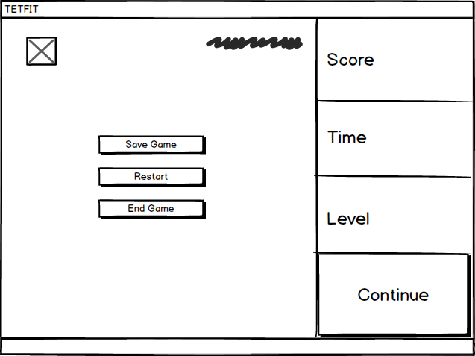

Figure 16 : Pause Menu Screen

In the game Pause Menu we will have many options to control the flow of the game. Firstly, you can keep going to play by clicking to the “Continue”. “Save Game” options will redirect you to the save game screen where you can save your game. “Restart” button will going to drive you to the first stage of the game where you start your level. It will going to start with your initial level speed. “End Game” button will bring you to the screen “Highscore” for you to send your score, if you would like. Game will have sound on/off button at the left upper corner.

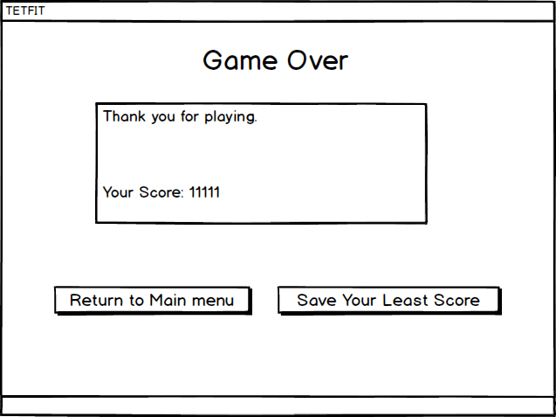

Figure 17 : Game Over Screen

On The “Game Over” screen, game will have a text that indicates you lost the game. Below that game will have a textarea that gives you info about your score. Game thanks you that you play this adventure. There will be 2 buttons that one of them indicates you that to return to the main menu and the other one to save your latest score with buttons “return to Main Menu”, ”Save Your Last Score”, respectively.

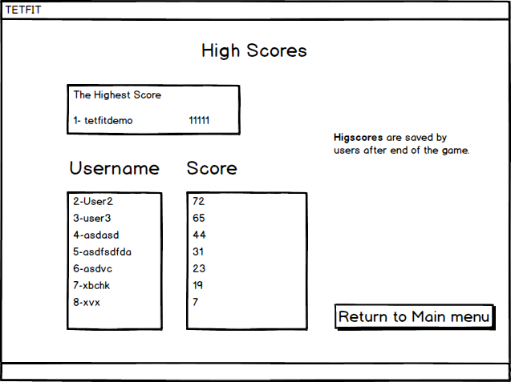

Figure 18 : High Score Screen

On the High Score Screen game will have indicator of High Score page as a text. Below that there will be the most scorer player on the game on the separated section of the other player. Below that other high score will be lined in descending order with player’s high scores and the nicknames. There will be a button that can bring you to the Main menu of the game which’s indicator is “Return to Main Menu”.

**References**